**Advanced Java:**

**What is JSP and Servlets:**

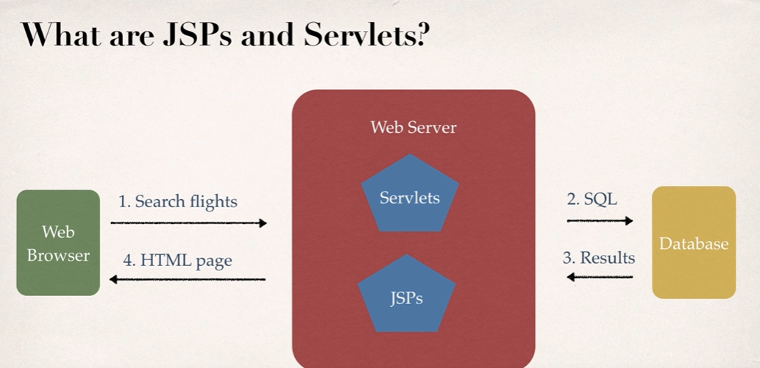

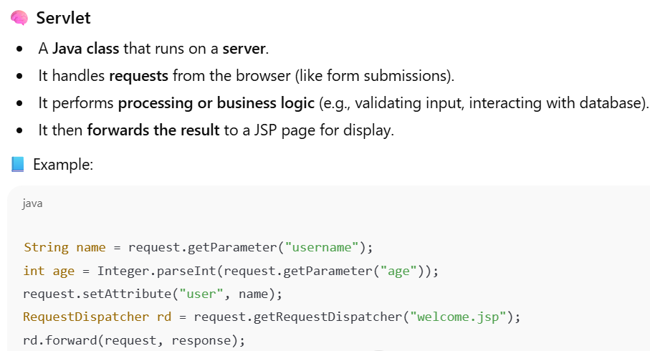

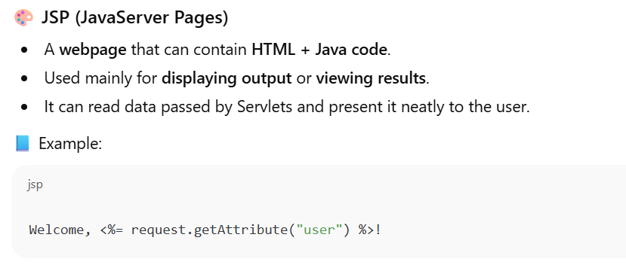

**Diagram:**

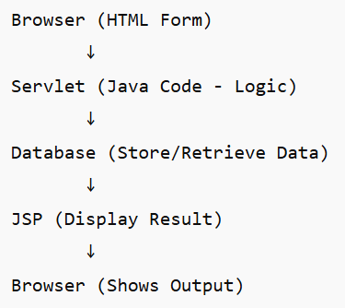

**Flow**:

1. **Browser (Client)**  
   → Sends a request (e.g., submitting an HTML form or clicking a link).  
   Example:

<form action="LoginServlet" method="post">

Username: <input name="user">

Password: <input name="pass">

<input type="submit">

</form>

1. **Servlet (Controller)**  
   → Receives the request using HttpServletRequest.  
   → Processes the logic (validation, DB query, etc.).  
   → Optionally connects to the **Database** via JDBC.  
   → Stores the results (like success message or data).  
   → Forwards the request to a **JSP** for display.
2. **Database (Model)**  
   → Stores or retrieves the required data.  
   Example: SELECT * FROM users WHERE username=?
3. **JSP (View)**  
   → Receives processed data from Servlet.  
   → Displays the response (HTML + dynamic content).  
   Example: “Welcome, Suresh!”
4. **Browser (Client)**  
   → Finally receives the **HTML response** and displays it to the user.

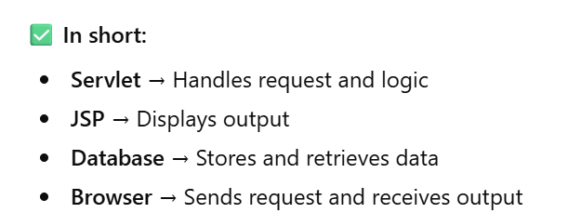

**Eclipse IDE:**

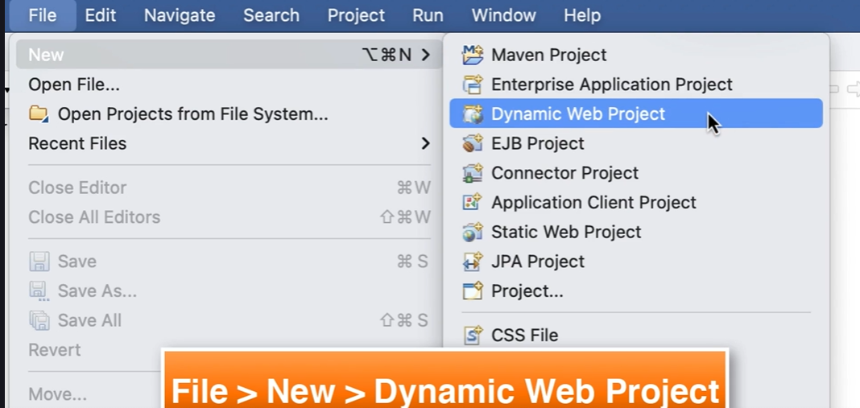

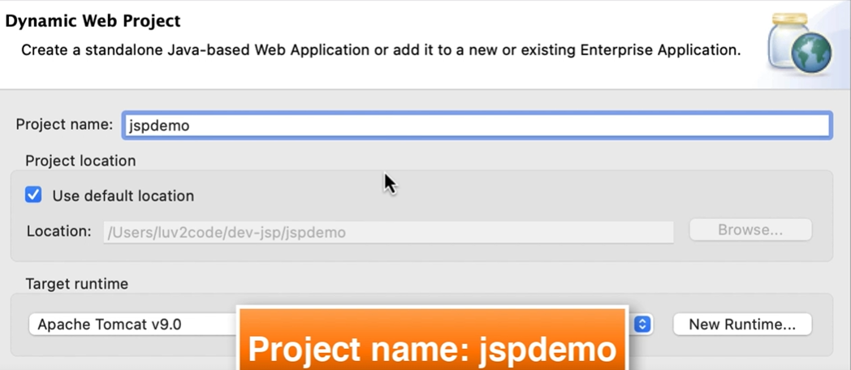

**Select Project Location 🡪 Click on Next**

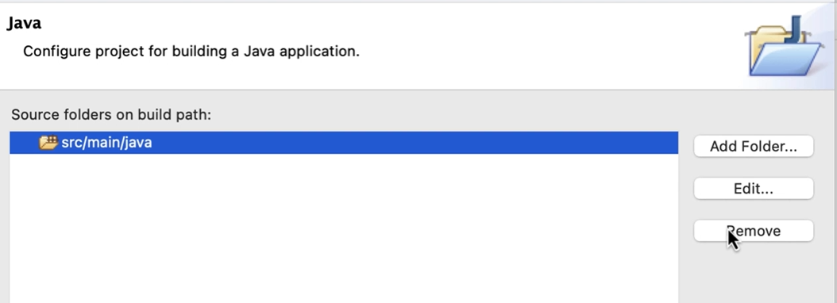

**Remove and add,**

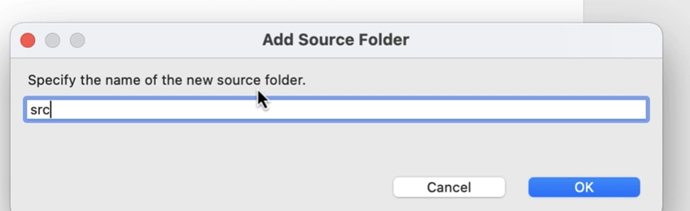

**Click Next and change Content Directory name. select Checkbox for web.xml**

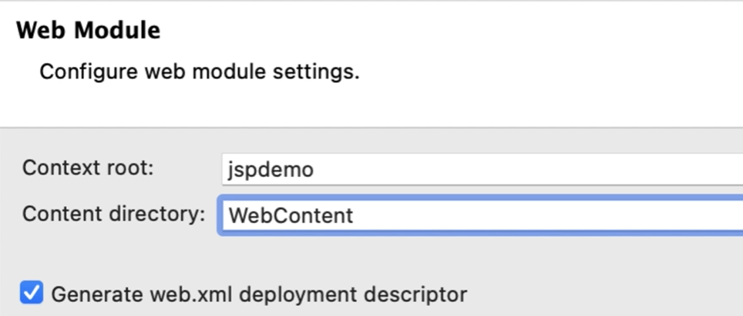

**Click on Finish**

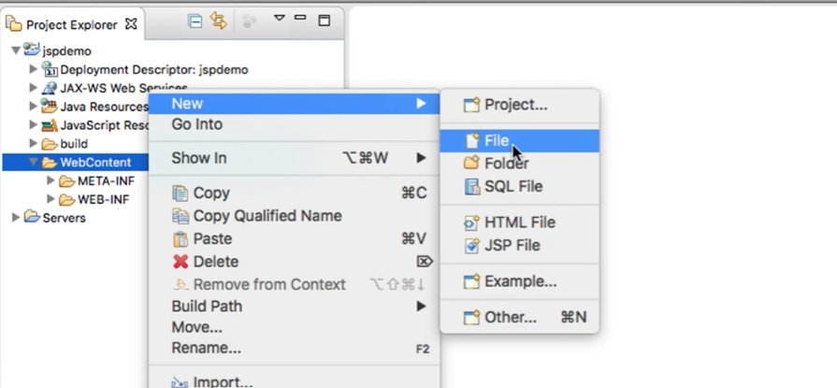

**JSP Hello World**

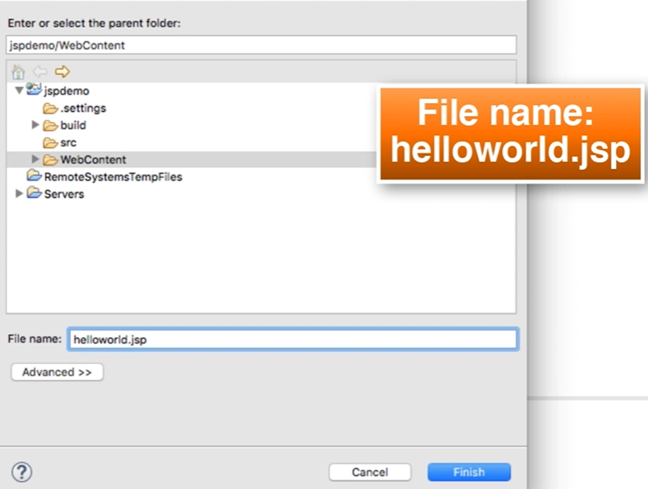

**Click on Finish.**

**Enter the program and click on save:**



**<html>**

**<body>**

**<h3>Hello World of Java!</h3>**

**The time on the server is <%= new java.util.Date() %>**

**</body>**

**</html>**

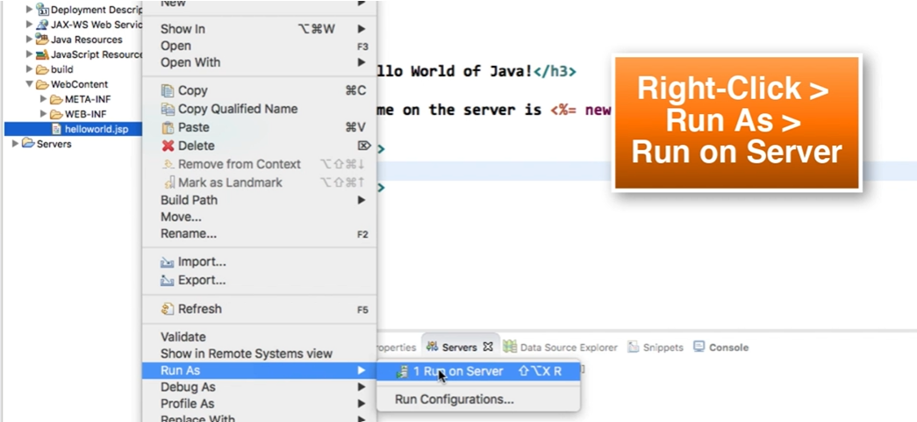

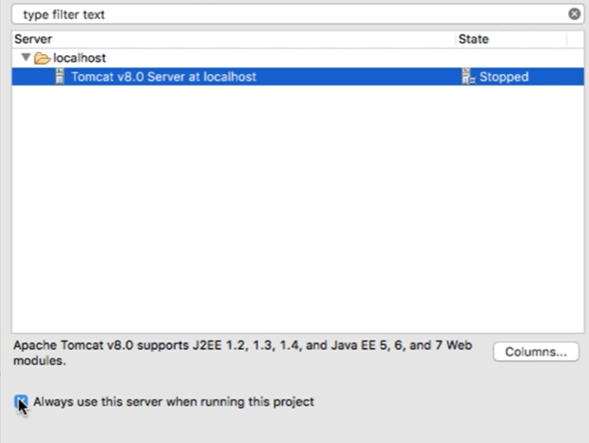

**Click on Finish**

**Note: Change server port and connector port if not working.**

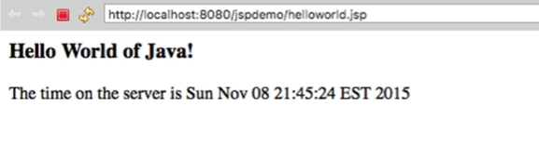

**Copy and Past the URl in any browser.**

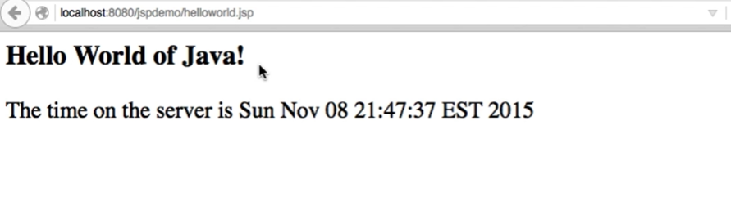

**Now, right + click and do view pagesource 🡪 which takes to the .jsp page**

**JSP Scripting Elements:**

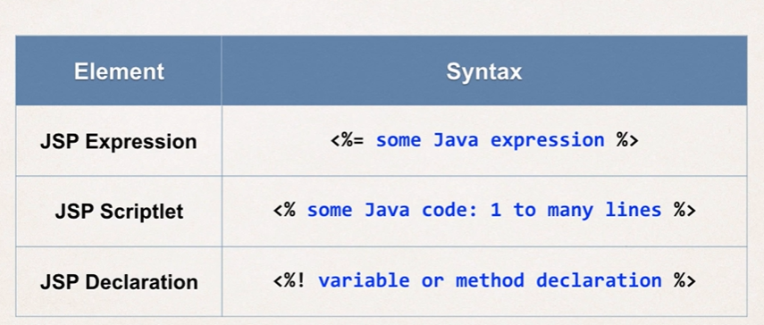

**JSP Expression:**



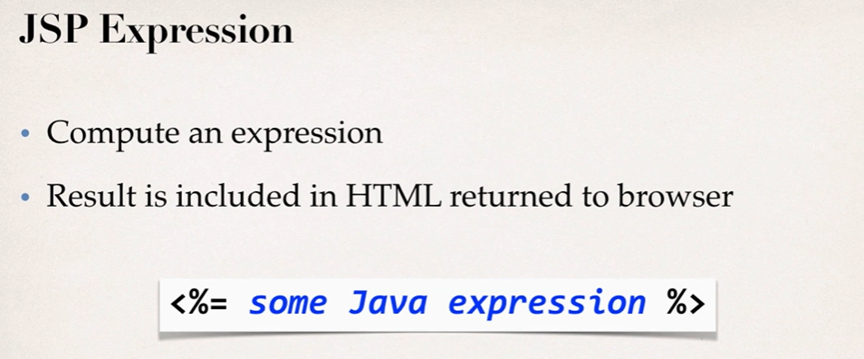

**Example1:**

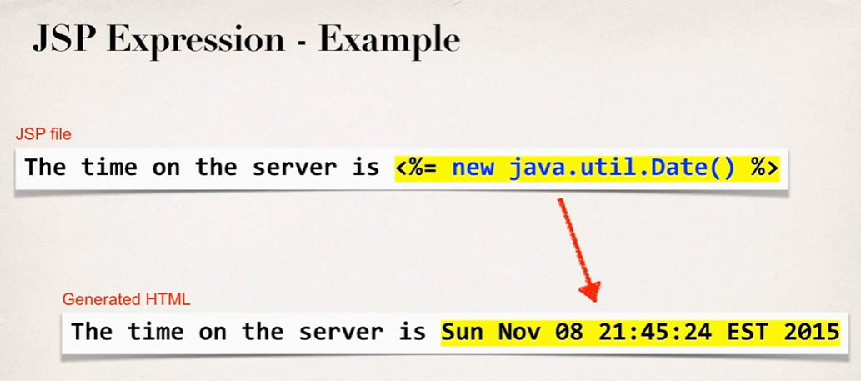

**Example2:**

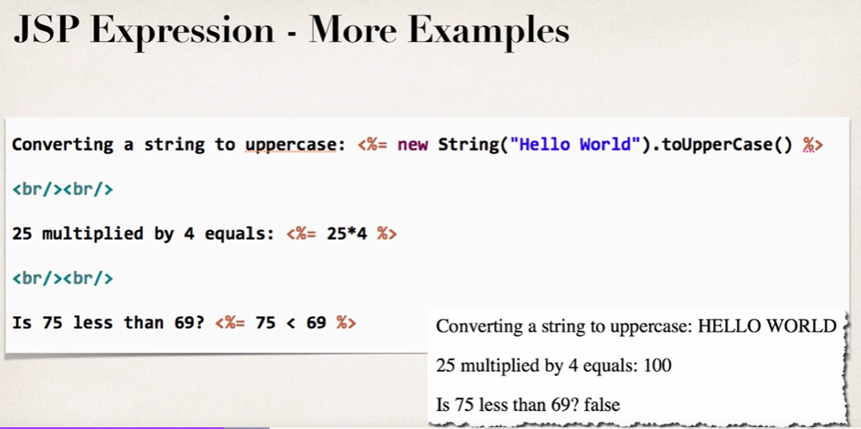

**JSP Scriplet:**



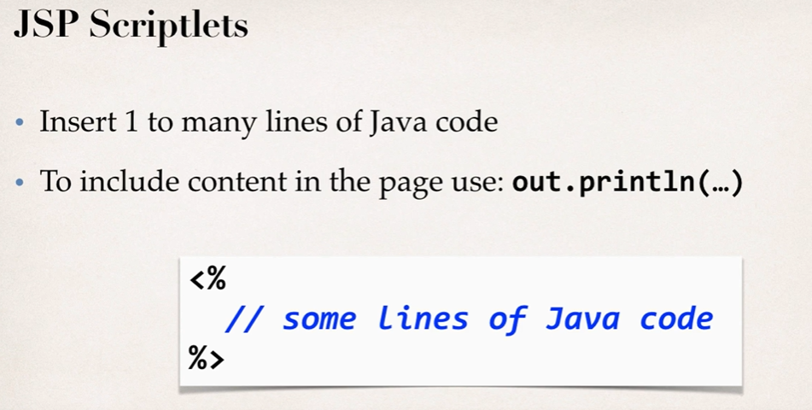

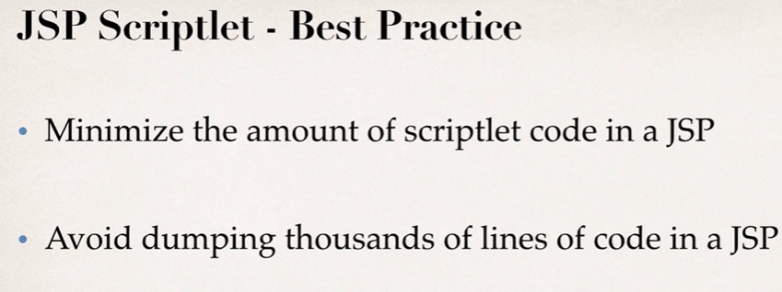

**JSP Declarations:**



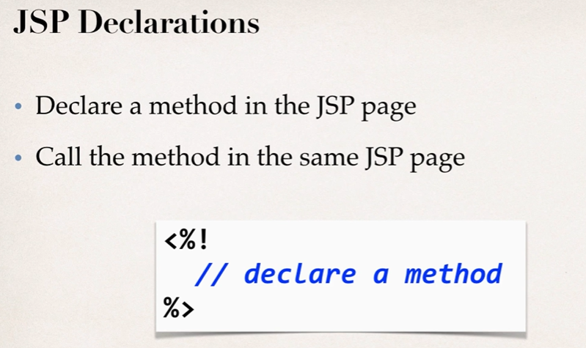

**Calling a Java Class from JSP**

1. Create a Java class
2. Call a java class from JSP.

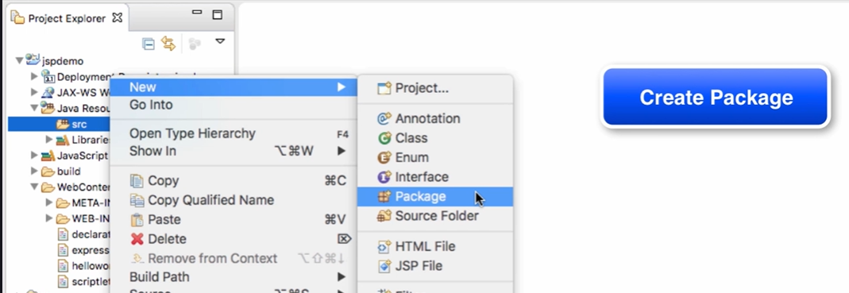

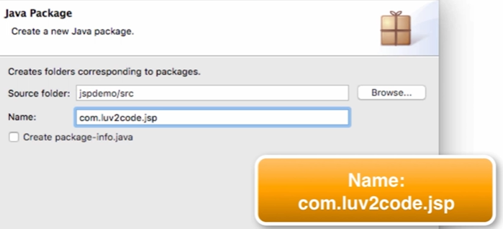

Click on Finish

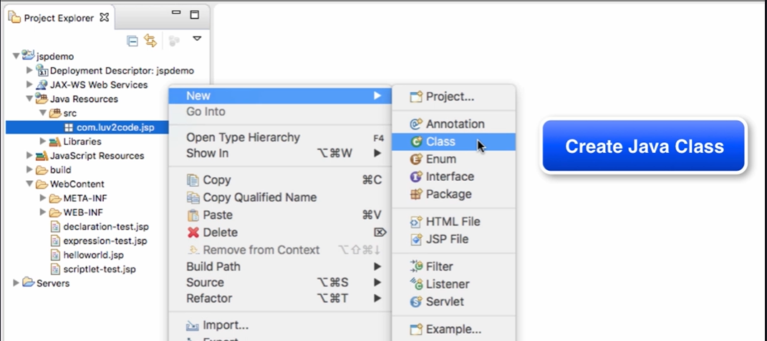

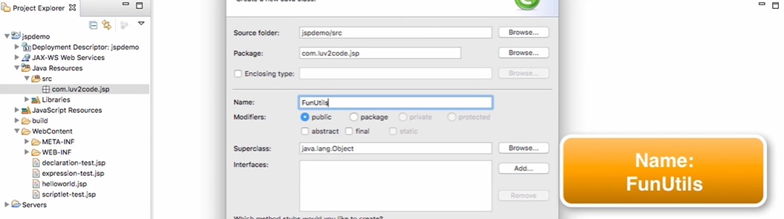

Click on Finish

**Enter the Java Code:**



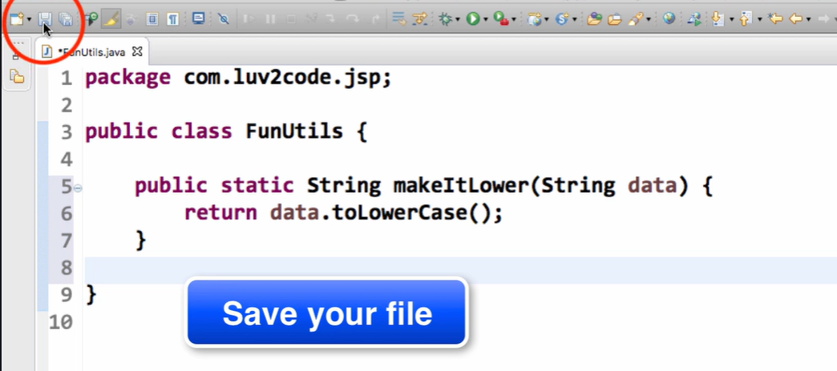

**Now, Create JSP file.**

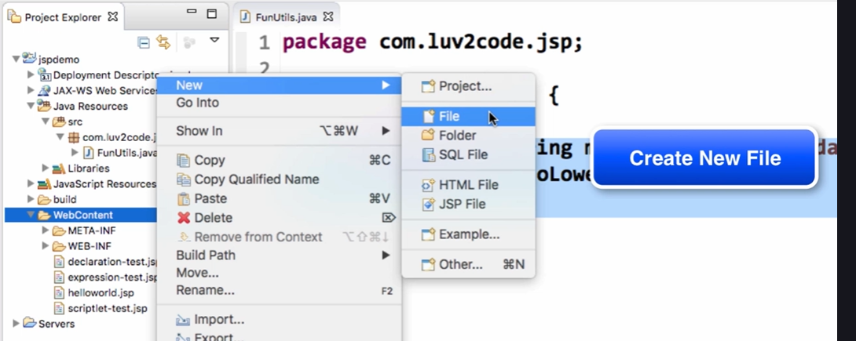

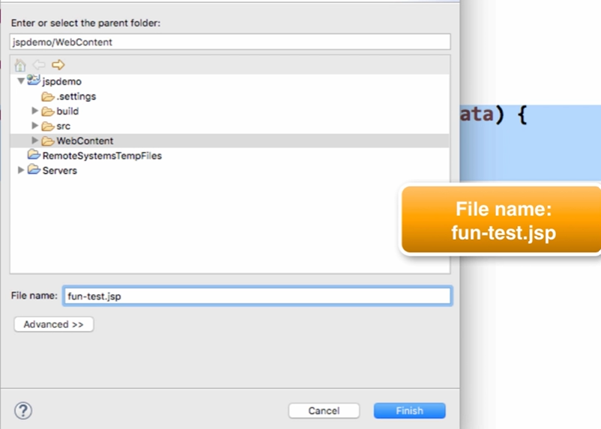

**Click Finish and enter the attached code below in JSP file.**



**Run as 🡪 Run on server**

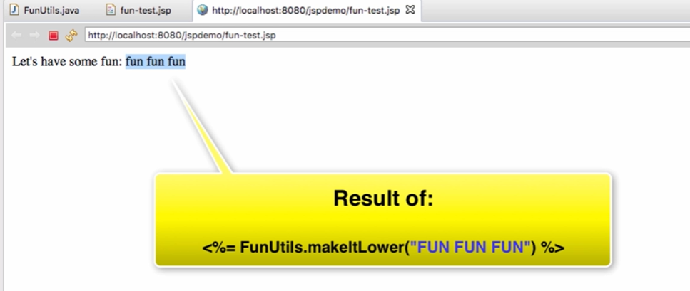

**JSP Built-in Objects:**

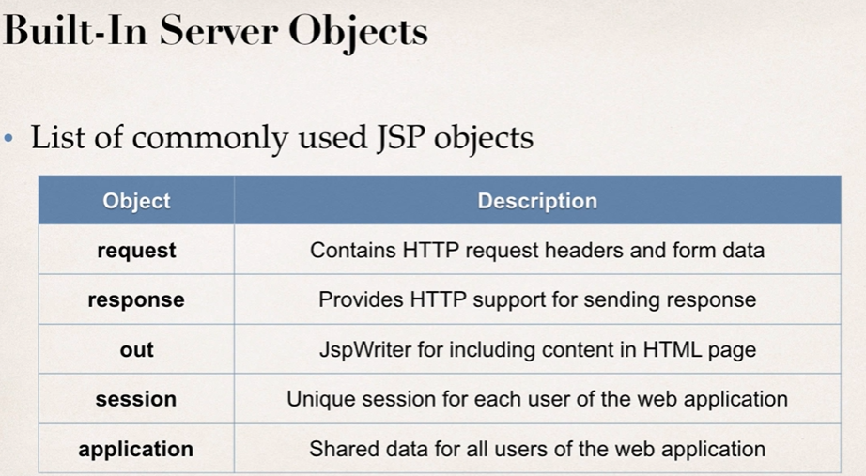

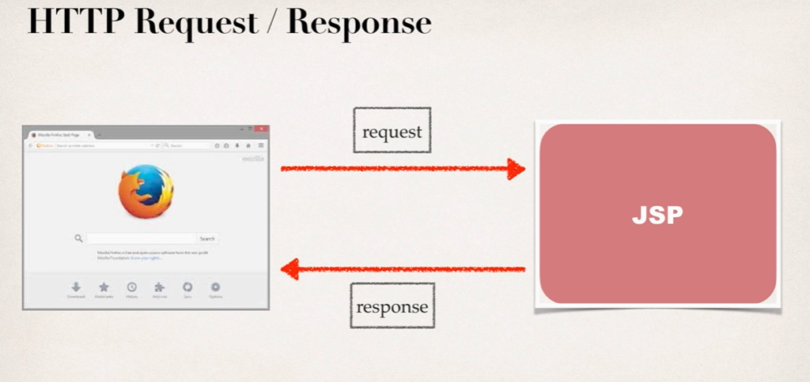

Create JSP file -> Run as 🡪 Run on server



**Output:**

Browser version etc.. with language used.

**Including Files in JSP**



Also Create, my-header.html

<h1 align=”center”>Java Class</h1>

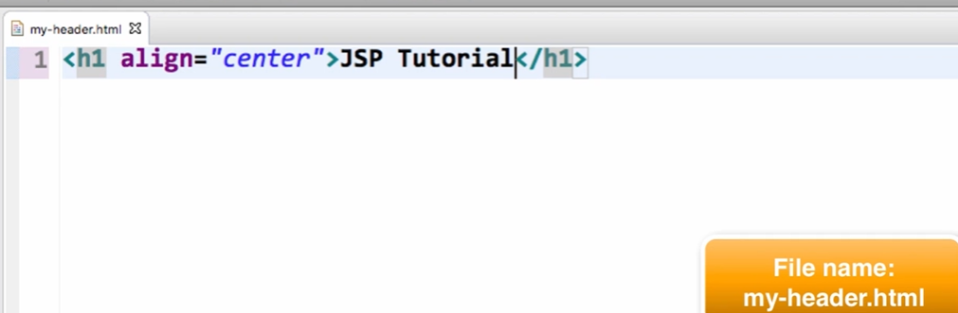

Homepage.jsp 🡪 Run as 🡪 Run on Server